

HOW TO ACCESS ELEARNING
- Email your Learning and Development Team at training@cso.ie to request an account
- The team will issue you with your credentials
- To access Percipio, please click into Lotus Notes and click on the Learning & Development tab, and click on eLearning
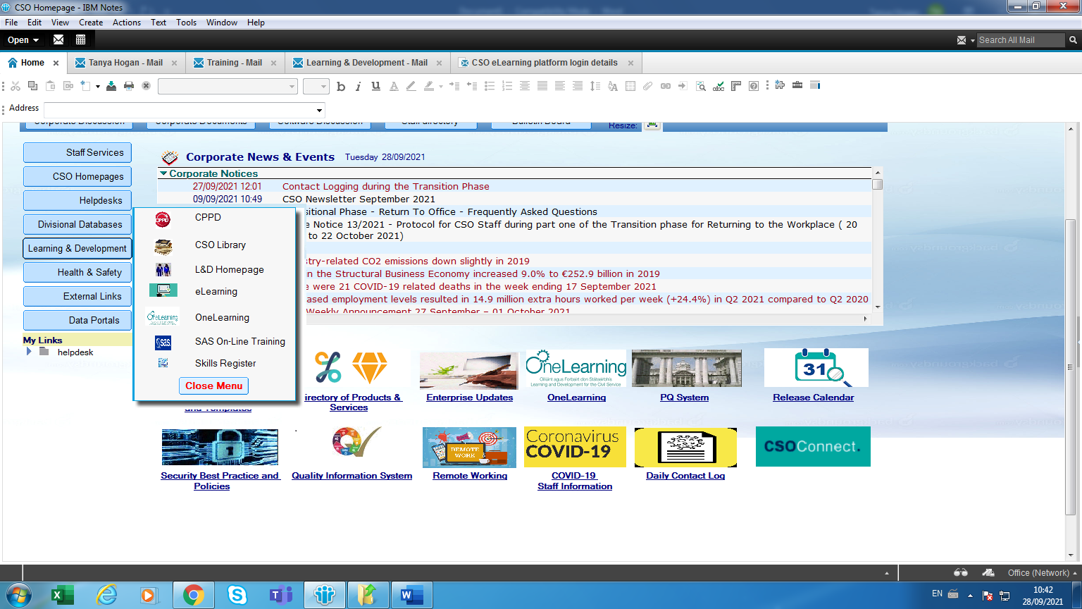
Any questions please email training@cso.ie

